SIMATS ENGINEERING
NAME: A.Preetika Sudhakar
RREG NO. 192371073
COURSE NAME: Database Management Systems
COURSE CODE: CSA0501
Ex. No. : 6
SELECT with various clause – BETWEEN, IN, Aggregate function

AIM:
To view the records from the tables using SELECT commands with BETWEEN, IN, Aggregate functions.
DESCRIPTION:
➢ The BETWEEN operator allows you to specify a range to test. We often use the BETWEEN operator in the WHERE clause of the SELECT, INSERT, UPDATE, and DELETE statements.
➢ The IN operator allows you to determine if a specified value matches any one of a list or a sub query. ➢ MySQL provides many aggregate functions that include AVG, COUNT, SUM, MIN, MAX, etc. An aggregate function ignores NULL values when it performs calculation except for the COUNT function.
BETWEEN operator:
SELECTcolumn1,column2,...
FROMtable_name
WHERE expr [NOT] BETWEEN begin_expr AND end_expr;
IN operator:
SELECTcolumn1,column2,...
FROMtable_name
WHERE (expr|column_1) IN ('value1','value2',...);
Questions:
IN & BETWEEN
1. List the type of the courses “Statistics” and “Programming”
2. The instructor wants to know the CourseNos whose scores are in the range 50 to 80
AGGREGATE
1. Find the average mark of “C002”.
2. List the maximum, minimum mark for “C002”
3. List the maximum, minimum, average mark for each course
4. List the name of the courses and average mark of each course.
5. Calculate the sum of all the scores.
6. How many students are registered for each course? Display the course description and the number of students registered in each course.
7. How many courses did each student register for?

OUTPUTS:
IN & BETWEEN
1. List plots located in Salem and Chennai
SELECT plot_no, location FROM plots WHERE location IN ('Salem','Chennai');
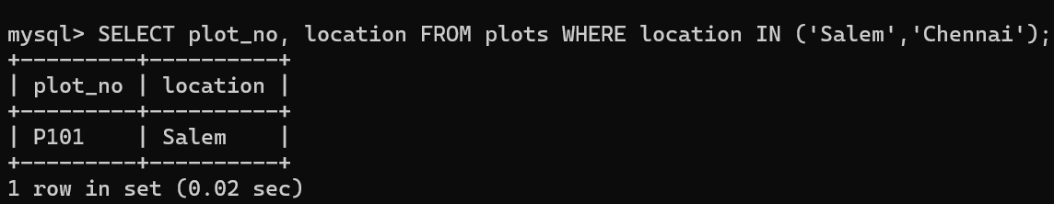

BETWEEN Operator

2. List plots whose price is between 13,00,000 and 18,00,000
SELECT plot_no, price FROM plots WHERE price BETWEEN 1300000 AND 1800000;
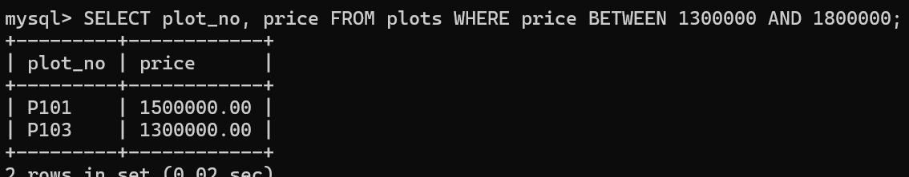

Aggregate Functions
1. Find the average plot price
SELECT AVG(price) AS average_price FROM plots;
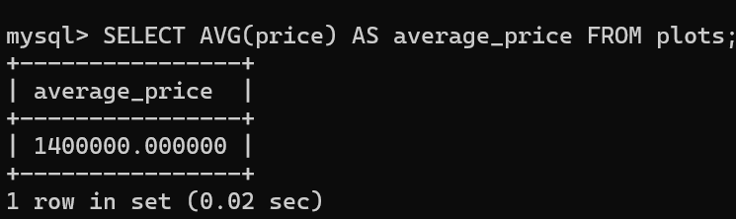

2. Find maximum and minimum plot price
SELECT MAX(price) AS maximum_price, MIN(price) AS minimum_price FROM plots;
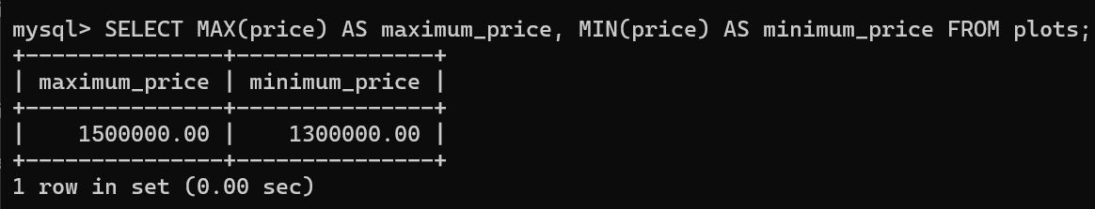

3. Find maximum, minimum and average area
SELECT MAX(area_sqft) AS maximum_area, MIN(area_sqft) AS minimum_area, AVG(area_sqft) AS average_area FROM plots;
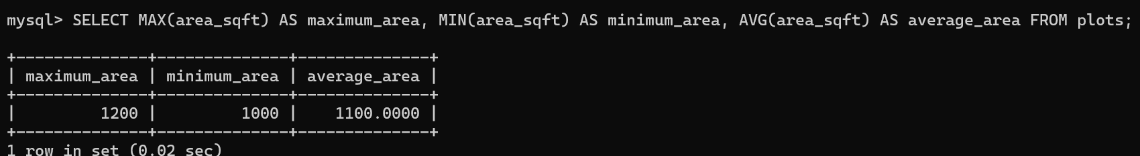

4. Display location and average plot price for each location
SELECT location, AVG(price) AS average_price FROM plots GROUP BY location;
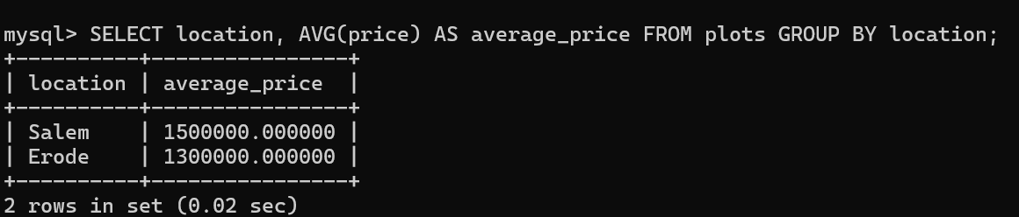

5. Calculate total amount received in payments
SELECT SUM(amount) AS total_payment FROM payments;
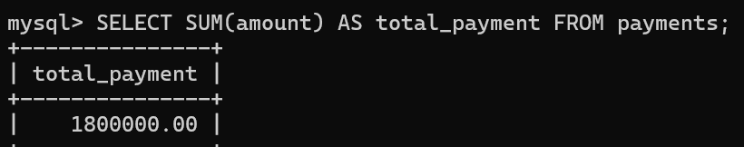

6. Count number of plots in each location
SELECT location, COUNT(*) AS total_plots FROM plots GROUP BY location;
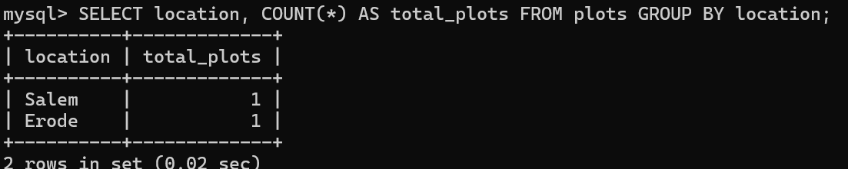

7. Count how many plots each owner has
SELECT owner_id, COUNT(*) AS total_plots FROM plots GROUP BY owner_id;
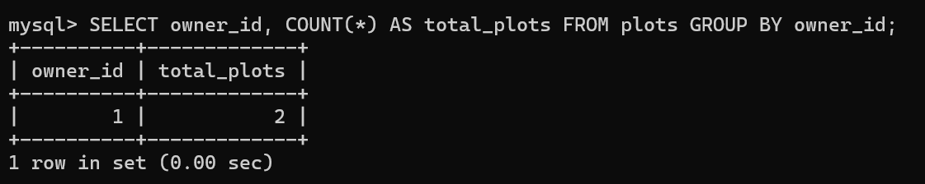

RESULT:
The records from the tables are displayed using SELECT commands with WHERE Clause and Pattern matching.

